PROPERTIES

1. **MARGIN**: The space outside the border of an element. It creates space around elements, outside of any defined borders.
2. 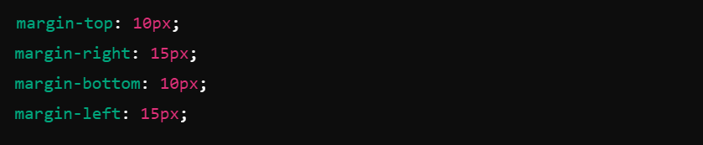**Individual margins**: Setting each margin side separately.
3. 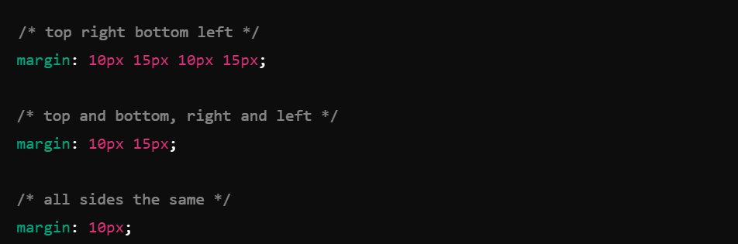**Shorthand margin property**: Setting all four margins at once using shorthand notation.
4. **Auto margin**: Centering an element horizontally within its container.
5. **BORDER**: The line surrounding the padding and content of an element. It can have various styles, widths, and colors.
6. 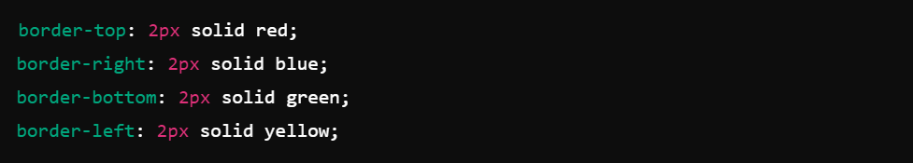**Individual borders**: Setting the border for each side separately.
7. **Shorthand border property**: Setting the border for all four sides at once.
8. **Border width**: Setting the width of the border.
9. **Border style**: Setting the style of the border. Common values include:

* none: No border.
* solid: A solid line.
* dotted: A series of dots.
* dashed: A series of dashes.
* double: Two solid lines.
* groove: A 3D grooved border.
* ridge: A 3D ridged border.
* inset: A 3D inset border.
* outset: A 3D border.

1. **Border color**: Setting the color of the border.
2. **Shorthand for width, style, and color**: Setting all border properties at once using shorthand notation.
3. 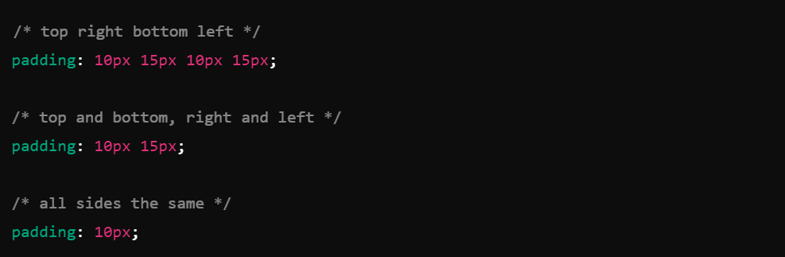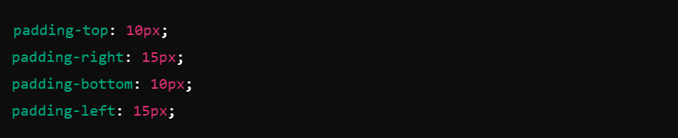**PADDING**: The space between the content of an element and its border. It creates space inside the element, between the content and the border.
4. **BOX-SHADOW**: A property that applies shadow effects to an element's frame, giving it a shadow around its box.
5. **BACKGROUND-COLOR**: Specifies the background color of an element.

* 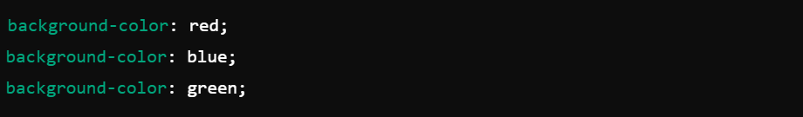**Named Colors**: CSS supports 140 named colors.
* 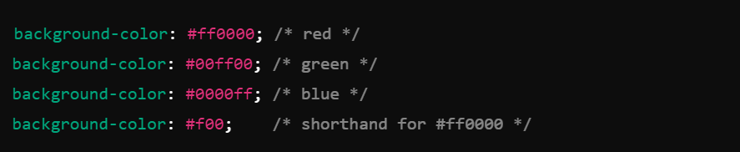**Hexadecimal Values**: Hex values start with a # followed by six or three hexadecimal digits.
* 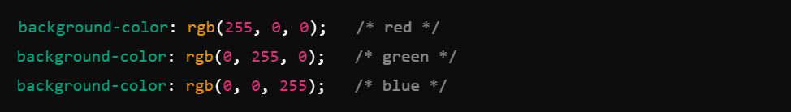**RGB Values**: RGB values define colors using the Red-Green-Blue model.
* 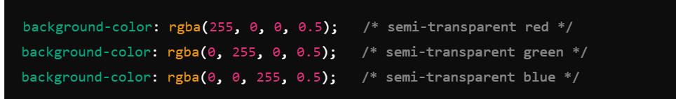**RGBA Values**: RGBA values are similar to RGB values but include an alpha channel to define opacity.
* 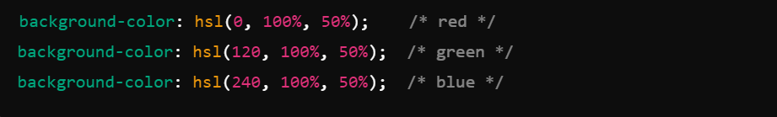**HSL Values**: HSL values define colors using the Hue-Saturation-Lightness model.
* 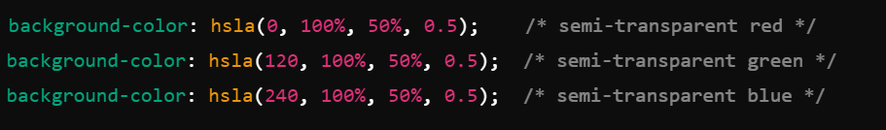**HSLA Values**: HSLA values are similar to HSL values but include an alpha channel to define opacity.

1. **DISPLAY**: Defines the display behavior of an element. Common values include block, inline, flex, and none.

* 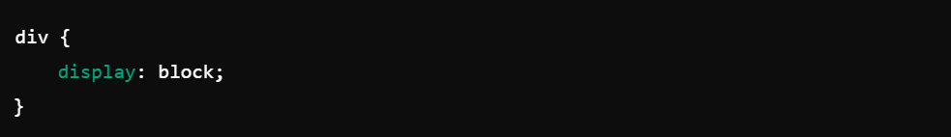**Block Level Element**:
* 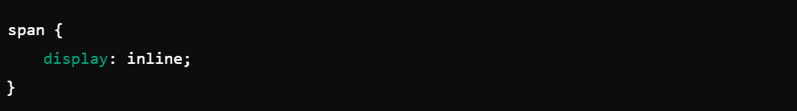**Inline Element**:
* 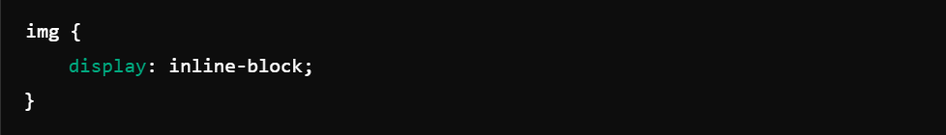**Inline-Block Element**:
* 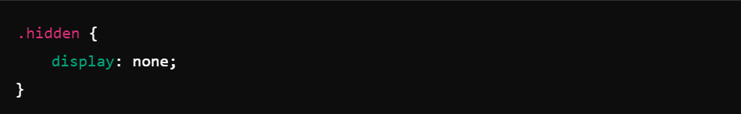**Hidden Element**:
* 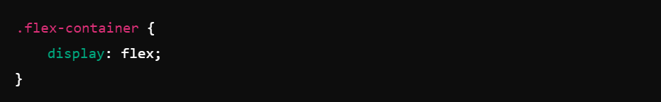**Flex Container**:
* 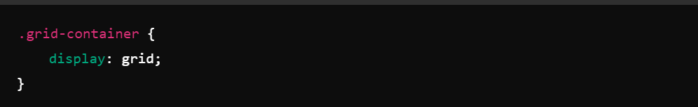**Grid Container**:

1. **POSITION**: Specifies the type of positioning for an element. Common values include static, relative, absolute, fixed, and sticky.

* 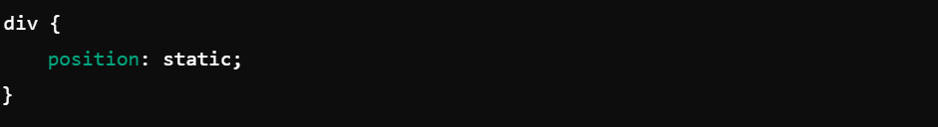Static Positioning (Default)
* 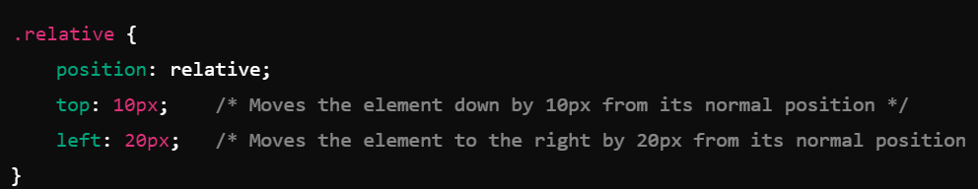relative element will be offset from its normal position.
* 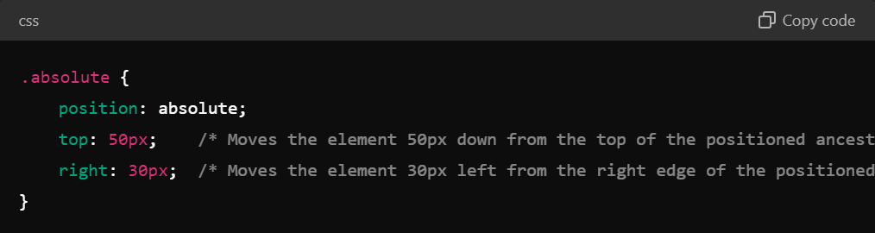absolute element will be positioned relative to the .container.
* 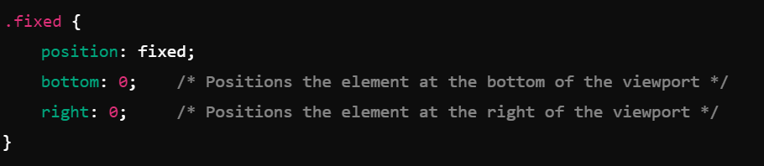fixed element will stay at the bottom-right of the viewport even when scrolling.

* 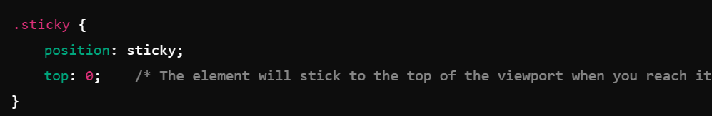sticky element will stick to the top of the viewport once it reaches the top while scrolling.

1. **WIDTH**: Sets the width of an element.

* Fixed **Width**: The. fixed-**width** element has a fixed width of 200px.
* Percentage **Width**: The. percentage-**width** element takes up 50% of the container's width.
* Viewport **Width**: The. viewport-**width** element is 50% of the viewport width.
* Relative **Width**: The. relative-**width** element’s width is based on 10 times the font size.
* 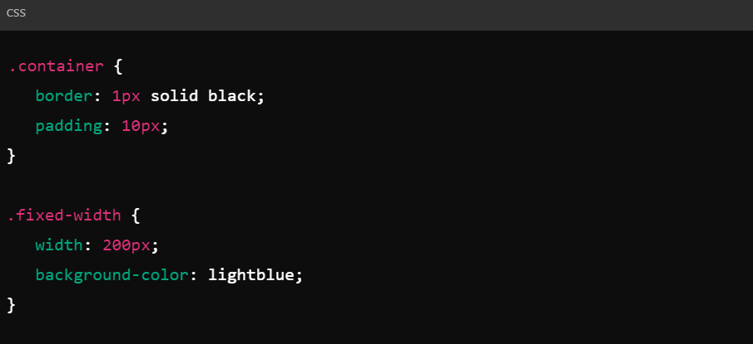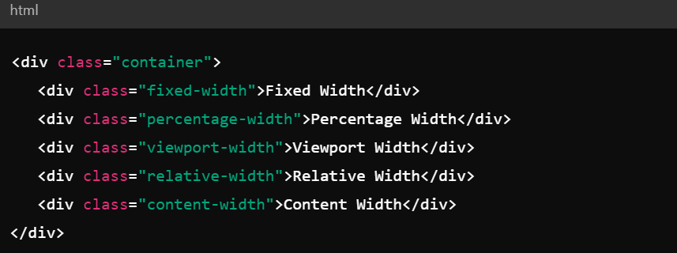Content **Width**: The. content-width element adjusts to fit its content.

1. 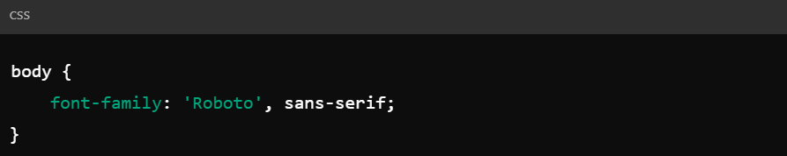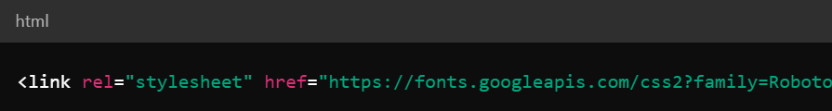**FONT-FAMILY**: Defines the font of an element. Multiple fonts can be listed as fallbacks.

1. 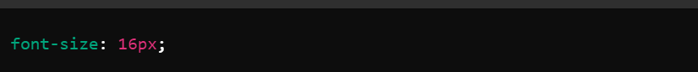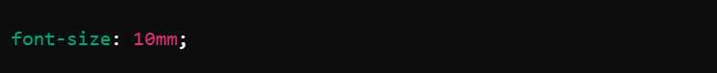**FONT-SIZE**: Sets the size of the font.

1. **FONT-STYLE**: Specifies the style of the font, such as normal, italic, or oblique.

* Normal: The default value. Text is displayed in the normal font style, which means it is not italicized or oblique.
* Italic: Text is displayed in an italicized style. This is typically used for emphasis or to represent quoted text.
* Oblique: Text is displayed in an oblique style. This is similar to italic but may not be as slanted. The exact appearance can vary depending on the font.
* Initial: Sets the property to its default value (usually normal), which is useful if you want to override other styles.
* Unset: Resets the property to its natural value based on its context. If inherited, it will act as if it was not specified.

1. 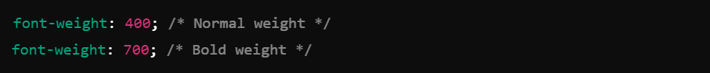**FONT-WEIGHT**: Defines the weight (or boldness) of the font, ranging from normal to bold and numerical values from 100 to 900.

* normal: Equivalent to 400.

* bold: Equivalent to 700.

* bolder: Relative to the parent element’s font weight. This makes the text bolder.

* lighter: Relative to the parent element’s font weight. This makes the text lighter.

1. **TEXT-ALIGN**: Specifies the horizontal alignment of text within an element. Common values include left, right, center, and justify.



1. 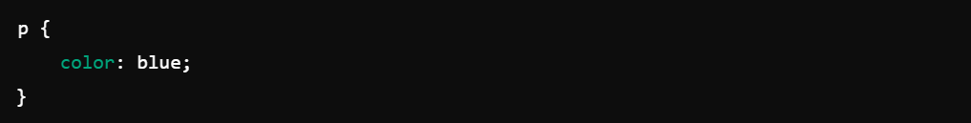**COLOR**: Sets the color of the text.

* **Hexadecimal color** values start with a # followed by 3 or 6 hexadecimal digits. The 3-digit format is a shorthand for the 6-digit format.
* **RGB** stands for Red, Green, and Blue. You specify the intensity of each color component with values between 0 and 255.
* **RGBA** is similar to RGB but includes an alpha (opacity) component. The alpha value ranges from 0 (fully transparent) to 1 (fully opaque).
* **HSL** stands for Hue, Saturation, and Lightness. The hue is specified in degrees (0–360), while saturation and lightness are percentages.
* **HSLA** is similar to HSL but includes an alpha (opacity) component.
* 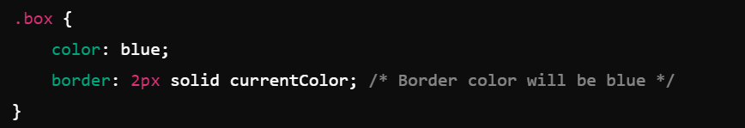The **current Color** keyword uses the value of the color property of the element itself. This is useful for maintaining consistency in designs where the color needs to match.